**Garage Management System**

**Project Title:** Garage Management System(Salesforce)

**College Name**: Sheshadri Rao Gudlavalleru Engineering College

**Team id**:- LTVIP2025TMID30221

**Team Members:**

|  |  |
| --- | --- |
| Name | Email ID |
| Konatham Sai Giri Raj Charan | charankonatham28@gmail.com |
| Bhavana Mannam | mannambhavana313@gmail.com |
| Emadabattina Lakshman | lakshmanlakshman56367@gmail.com |
| D Sai Nandini | durgamnandini1153@gmail.com |

**II.Project Overview:**

This project implements a comprehensive Garage Management System leveraging the Salesforce platform. The system streamlines various aspects of garage operations, including customer management, appointment scheduling, service record keeping, billing, and reporting, to enhance efficiency and customer satisfaction.

**Objectives:**

To develop a centralized system for managing customer information and vehicle service history.

To automate the appointment scheduling process and send timely notifications.

To efficiently track and manage service records, including repairs and part replacements.

To facilitate accurate billing and feedback collection from customers.

To generate insightful reports and dashboards for better business decision-making.

To improve overall operational efficiency and customer experience within a garage setting.

Phase-wise Documentation: This document details the different phases of the project, from ideation to implementation and testing, providing a thorough overview of the development process.

**Future Scope**:

• Add a mobile app for customers and staff

• Predict vehicle issues using AI

• Loyalty programs for repeat customers

• Connect with smart car diagnostics (IoT)

• Manage spare parts and inventory in real-time

• Expand to multiple garage branches

• Improve analytics with advanced dashboards

Conclusion

The **Garage Management System** on Salesforce streamlines appointments, service records, and billing for garages. It improves efficiency, customer experience, and record-keeping — while being scalable and ready for future upgrades like AI, mobile apps, and automation.

**III.Project Documentation Phases**

This section details the various phases of the Garage Management System project

Ideation Phase

Brainstorming: Initial ideas and concepts for the Garage Management System were brainstormed, focusing on key functionalities and user needs.

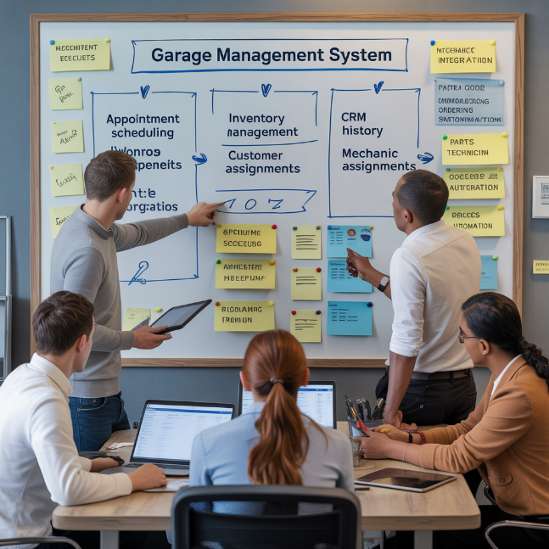

Empathy Map:

An empathy map was created to understand the target users (garage owners, mechanics, customers) and their needs, pain points, and motivations.

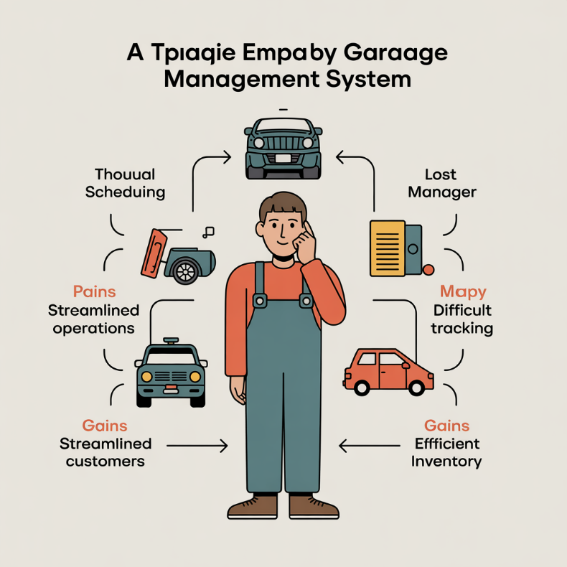

Problem Statement:

A clear problem statement was defined, outlining the challenges faced by traditional garage management and how this Salesforce solution aims to address them.

Customer Journey Map:

The customer journey map was developed to visualize the interaction flow between customers and the garage, identifying key touchpoints and opportunities for system intervention.

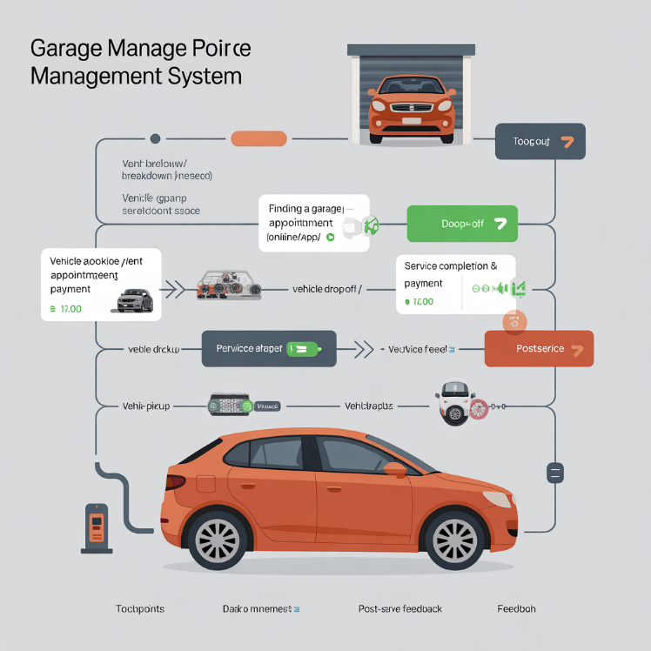

Data Flow Diagram:

A data flow diagram was designed to illustrate the movement of information within the system, from customer input to service record generation and billing.

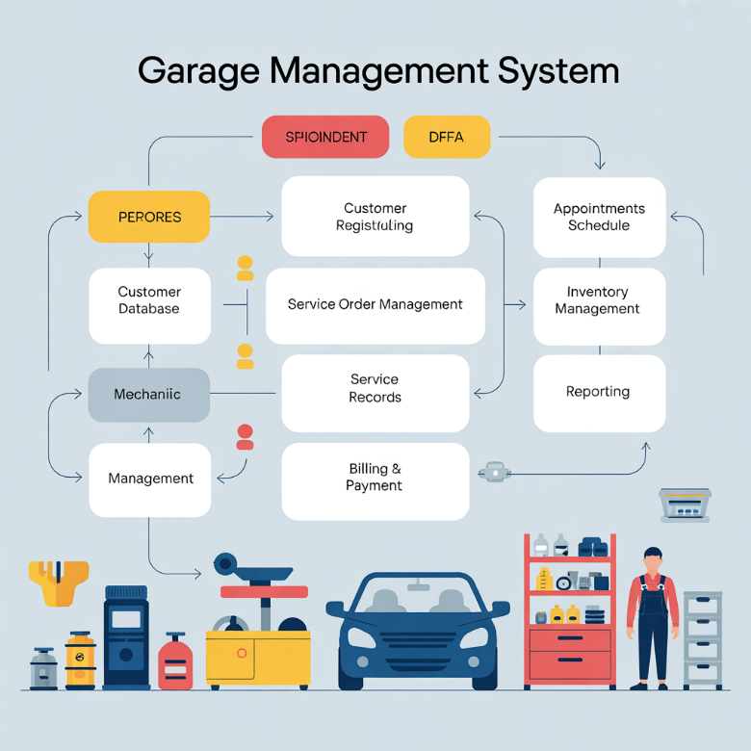

Solution Requirement:

Detailed functional and non-functional requirements for the system were gathered and documented.Technology Stack: Salesforce platform (Lightning Experience), Apex, Lightning Web Components (LWC) / Aura Components, Flows, Process Builders, Reports, and Dashboards.

**Project Design Phase**

Problem Solution Fit:

The proposed solution was carefully evaluated to ensure it effectively addresses the identified problems.

Proposed Solution:

A comprehensive solution involving custom objects, automation tools, and user interfaces within Salesforce was designed.

Solution Architecture:

The architecture of the Salesforce solution was planned, including data models, security, and integration points.

**Project Planning Phase**

Project Planning Template:

A detailed project plan was created, outlining timelines, resources, and milestones for development and deployment.

Project Executable Files

Project Files:

All Salesforce configuration files, Apex code, Lightning components, and other project-related assets.

Dataset:

Sample data used for testing and demonstration purposes.

**Functional and Performance Testing**

Performance Testing:

Testing was conducted to ensure the system performs efficiently under various load conditions.

Final Report:

This comprehensive document detailing all aspects of the project.

Video Demo Link:

A link to a video demonstration showcasing the system's functionalities.

**IV. Salesforce Implementation Details**

This section provides an in-depth look at the Salesforce configuration and development undertaken for the Garage Management System.

Custom Objects:

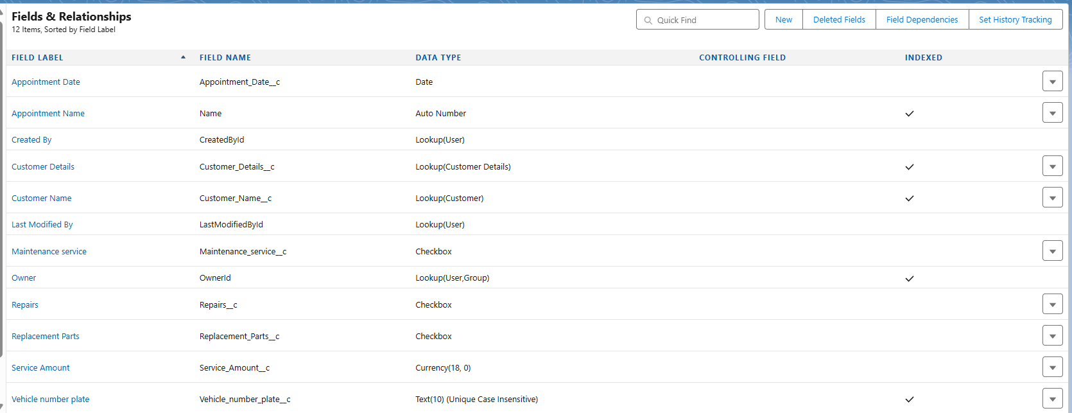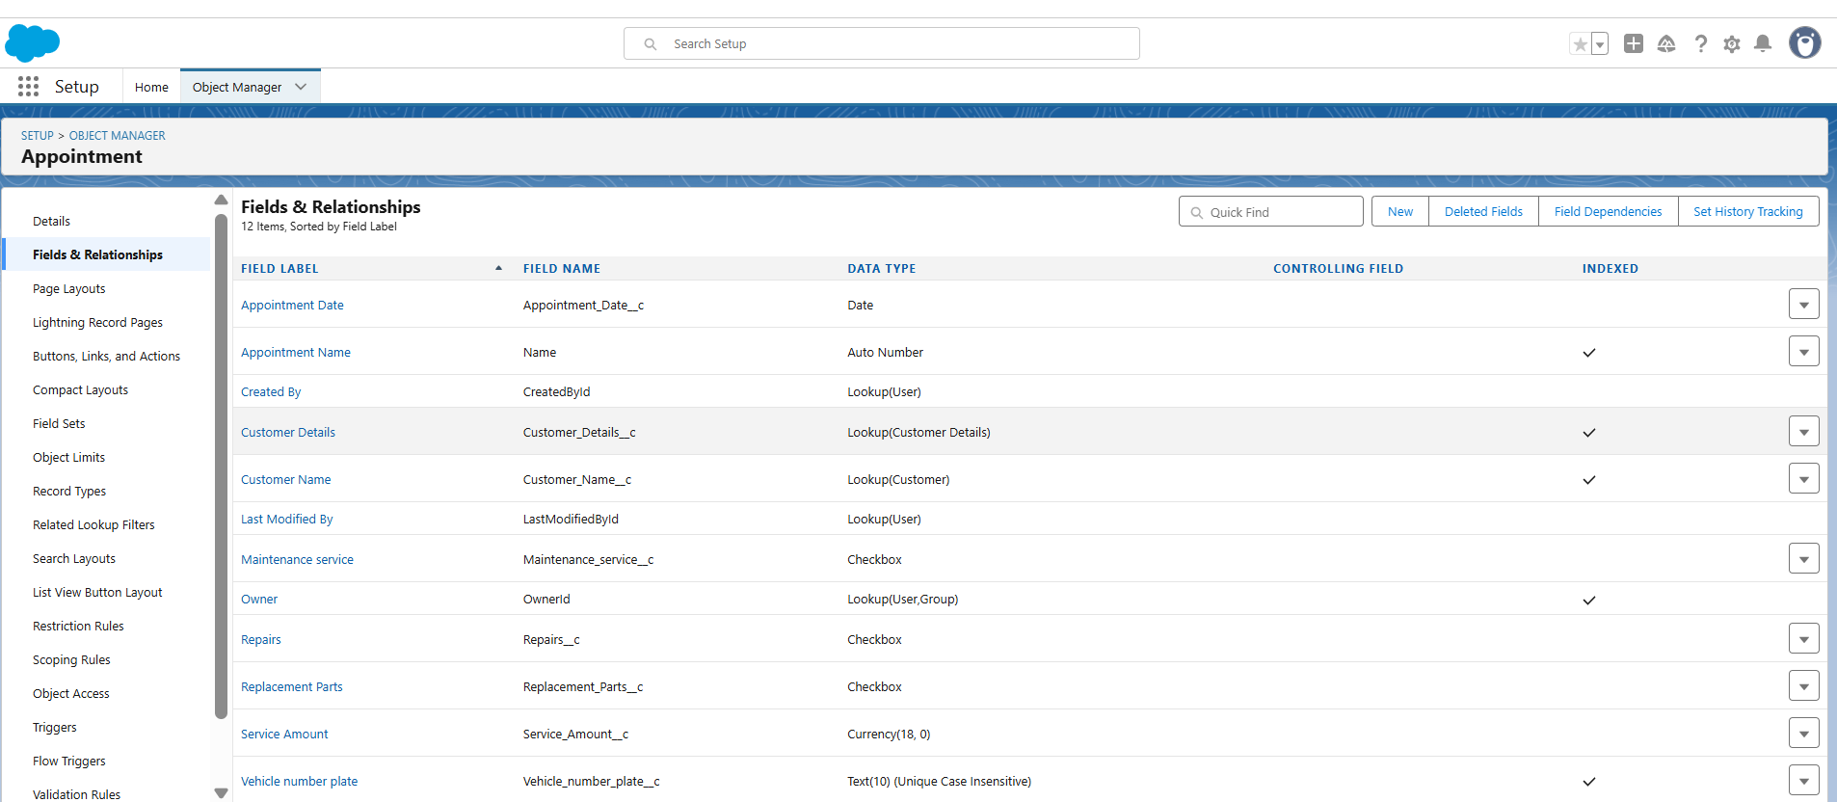

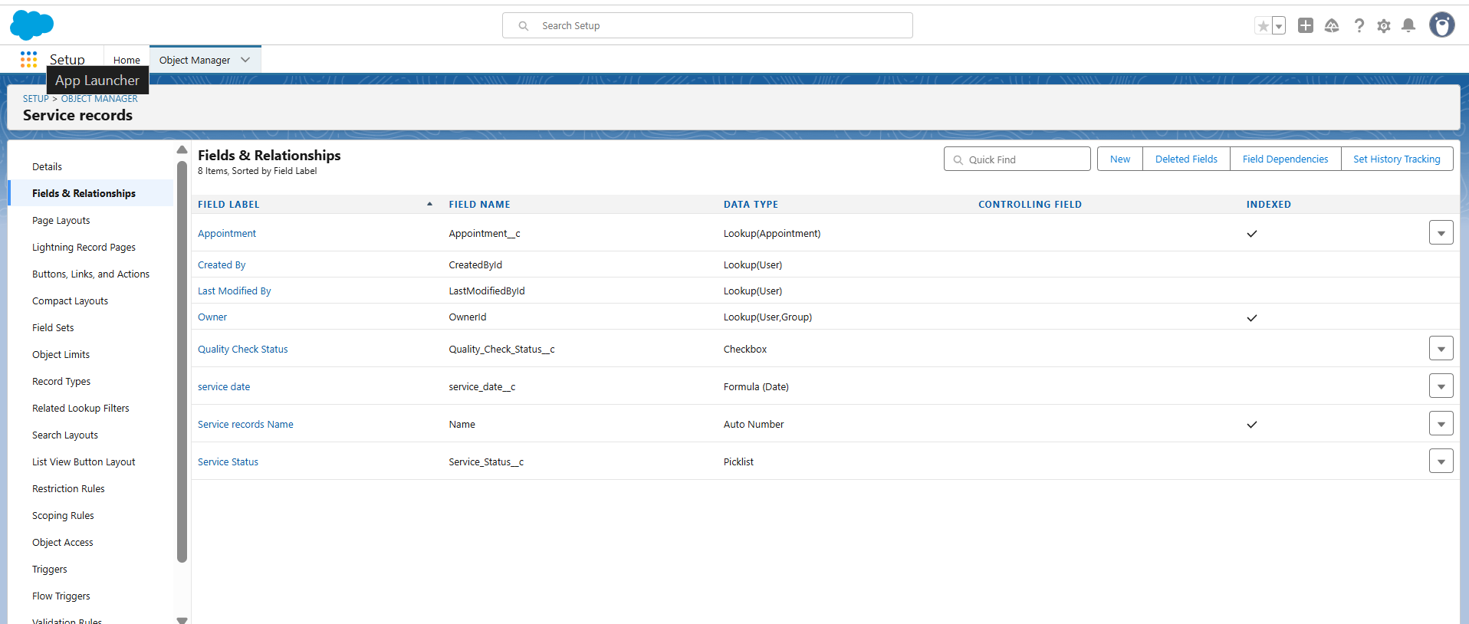

Customer Details:

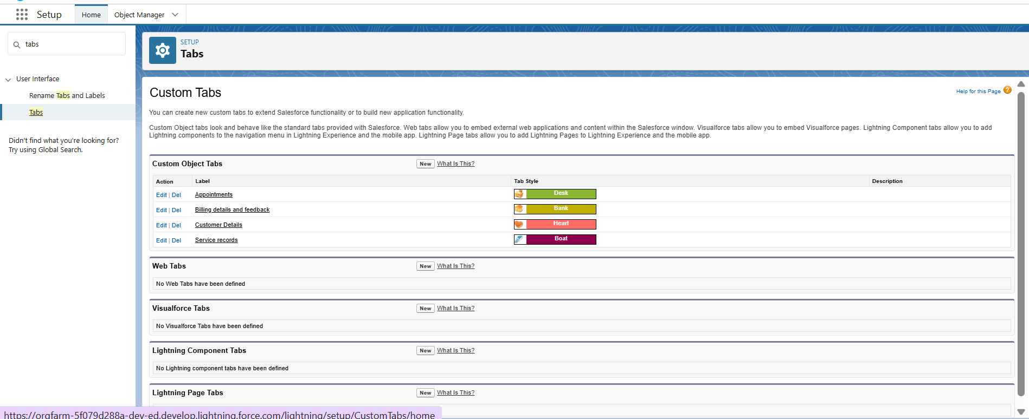

Purpose:

Stores essential information about each customer.

Fields:

Customer_Name__c (Text): Customer's full name.

Email__c (Email): Customer's email address.

Phone_Number__c (Phone): Customer's primary contact number.

(Standard fields like CreatedById, LastModifiedById, OwnerId are automatically included).

Screenshot Reference: Refer to "Customer Details - Fields & Relationships" screenshot for visual representation of these fields.

Appointment:

Purpose:

Manages scheduled appointments for vehicle services.

Fields:

Appointment_Date__c (Date): The date the appointment is scheduled for.

Appointment_Name (Auto Number): A unique identifier for each appointment.

Customer_Details__c (Lookup(Customer Details)): Links to the relevant customer record.

Maintenance_Service__c (Checkbox): Indicates if the appointment is for routine maintenance.

Repairs__c (Checkbox): Indicates if the appointment involves repair work.

Replacement_Parts__c (Checkbox): Specifies if new parts are required.

Service_Amount__c (Currency): The total estimated or final cost of the service.

Vehicle_Number_Plate__c (Text): The license plate number of the vehicle.

Validation Rule: Vehicle

Description: Ensures that the Vehicle_Number_Plate__c field adheres to a specific format.

Error Condition Formula: NOT(REGEX(Vehicle_Number_Plate__c, "^[A-Z0-9-]{4,10}$")) (Checks if the number plate contains 4-10 alphanumeric characters or hyphens).

Error Message: "Please enter valid number"

Screenshot Reference:

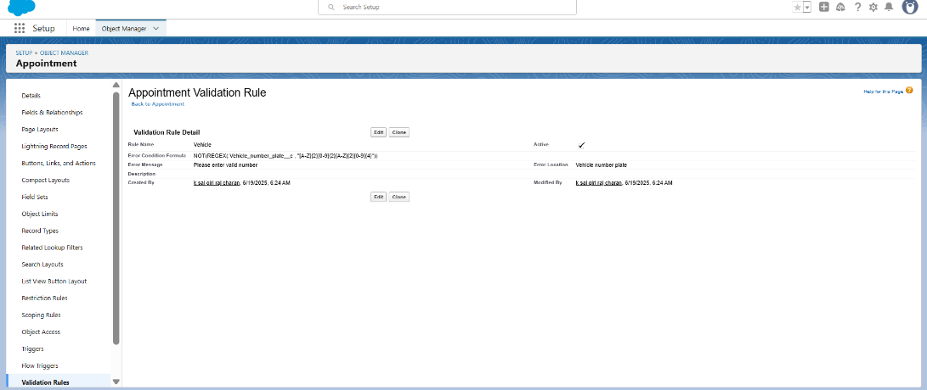

Service Records:

Fields:

Appointment__c (Lookup(Appointment)): Links to the associated appointment.

Quality_Check_Status__c (Checkbox): Indicates if a quality assurance check has been performed.

Service_Date__c (Formula(Date)): Derives the service date.

Service_Status__c (Picklist): Current status of the service (e.g., "Pending", "Completed").

Service_Records_Name (Auto Number): Unique identifier for each service record..

Billing Details and Feedback:

Validation Rule: rating_should_be_less_than_5

Description: Ensures customer ratings fall within an acceptable range (1 to 5).

Error Condition Formula: NOT(AND(Rating__c >= 1, Rating__c <= 5))

Error Message: "rating should be from 1 to 5"

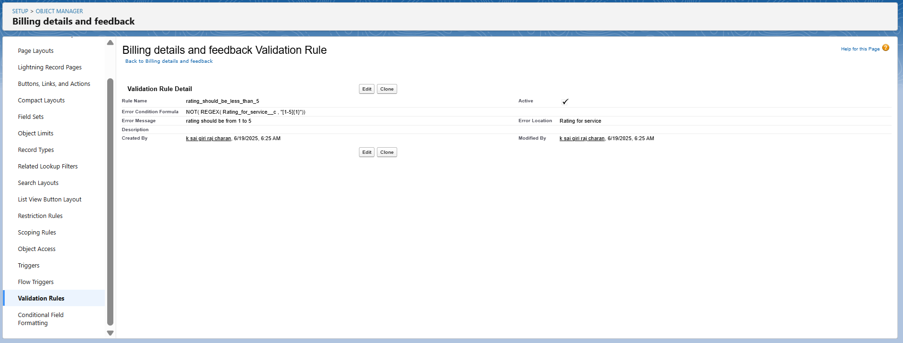

Custom Tabs:

Configured Tabs:

Appointments

Billing details and feedback

Customer Details

Service records

Lightning App:

App Name: Garage Management Application

Developer Name: Garage_Management_Application

Purpose: Provides a centralized and intuitive user interface for managing all aspects of garage operations.

Branding: Customized with a blue primary color and a distinct "GM" logo.

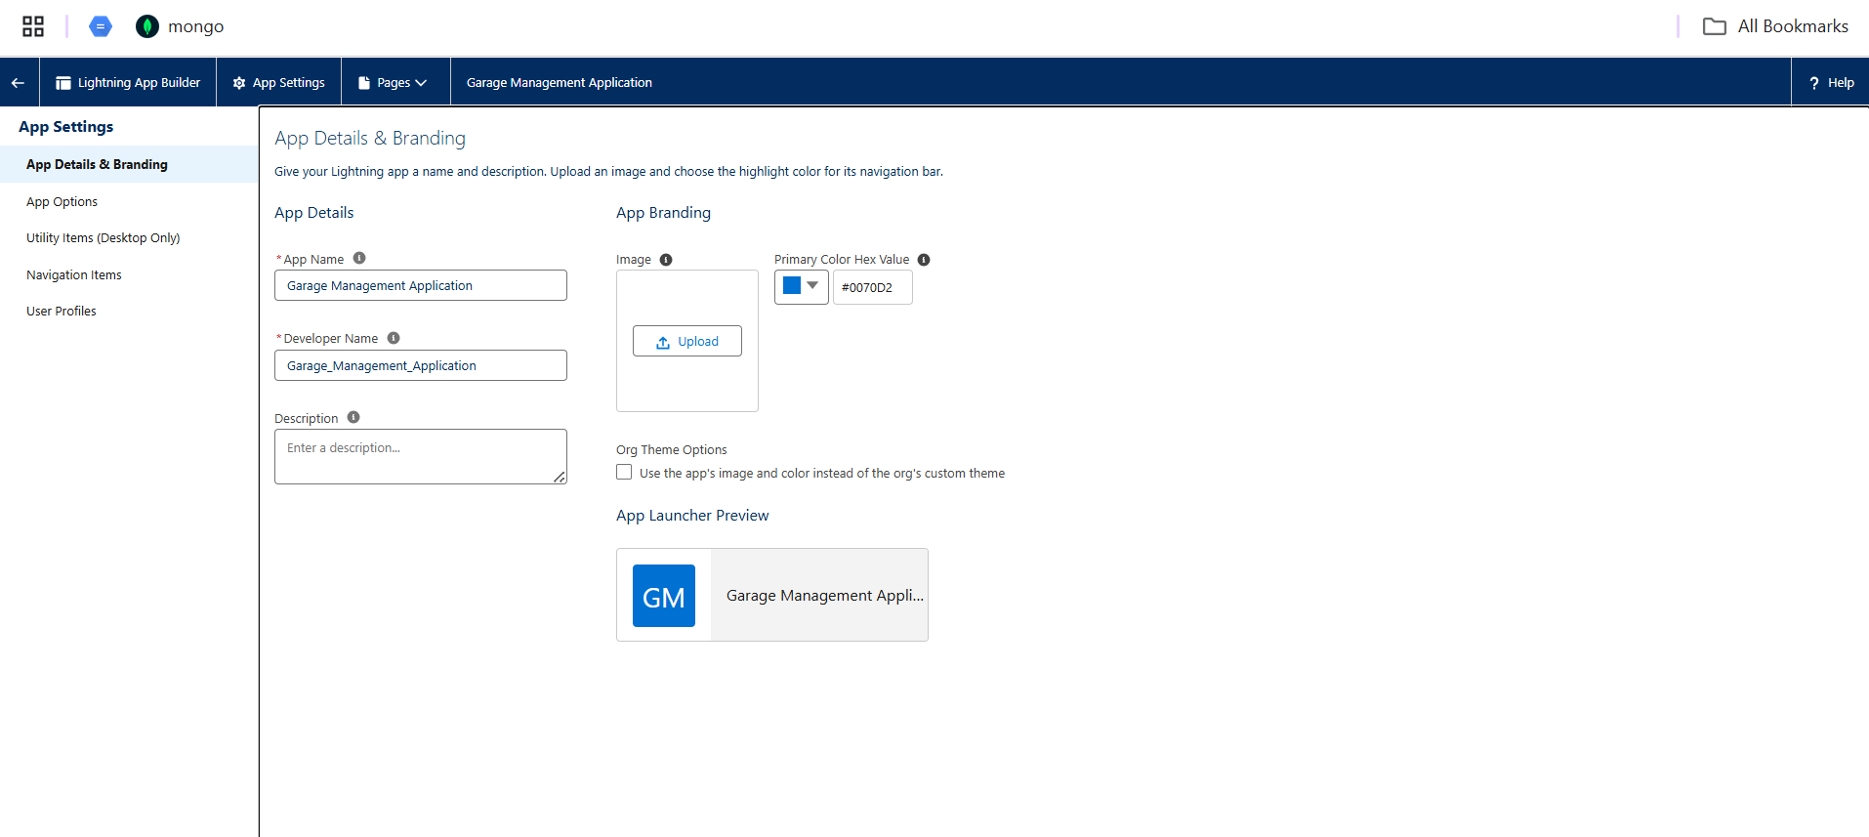

User Management:

Users:

Multiple users have been configured within the system, each assigned a specific profile and role to ensure proper access and segregation of duties.

Example Users:

k.sai (sales person)

integration (Analytics Cloud Integration User)

shibunathan (System Administrator)

nikhilkumar (Manager)

eric (System Administrator)

jack (sales person)

chutty (Chatter Free User)

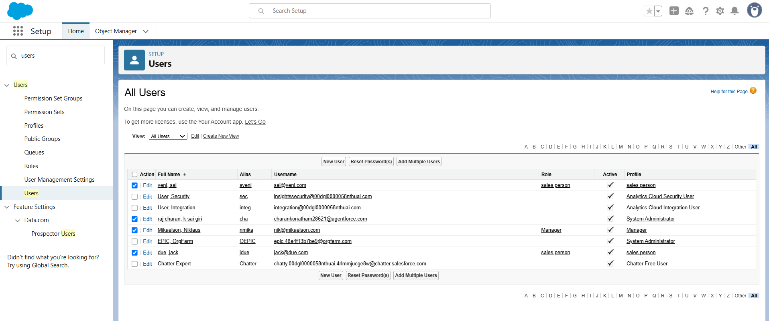

Public Groups:

Configured Group: sales team

Members: Includes users with the "sales person" role.

Screenshot Reference: Refer to "Public Groups - sales team" screenshot.

Profiles:

Manager Profile: This profile defines the permissions and access levels for users in managerial roles, including object, field, and layout assignments.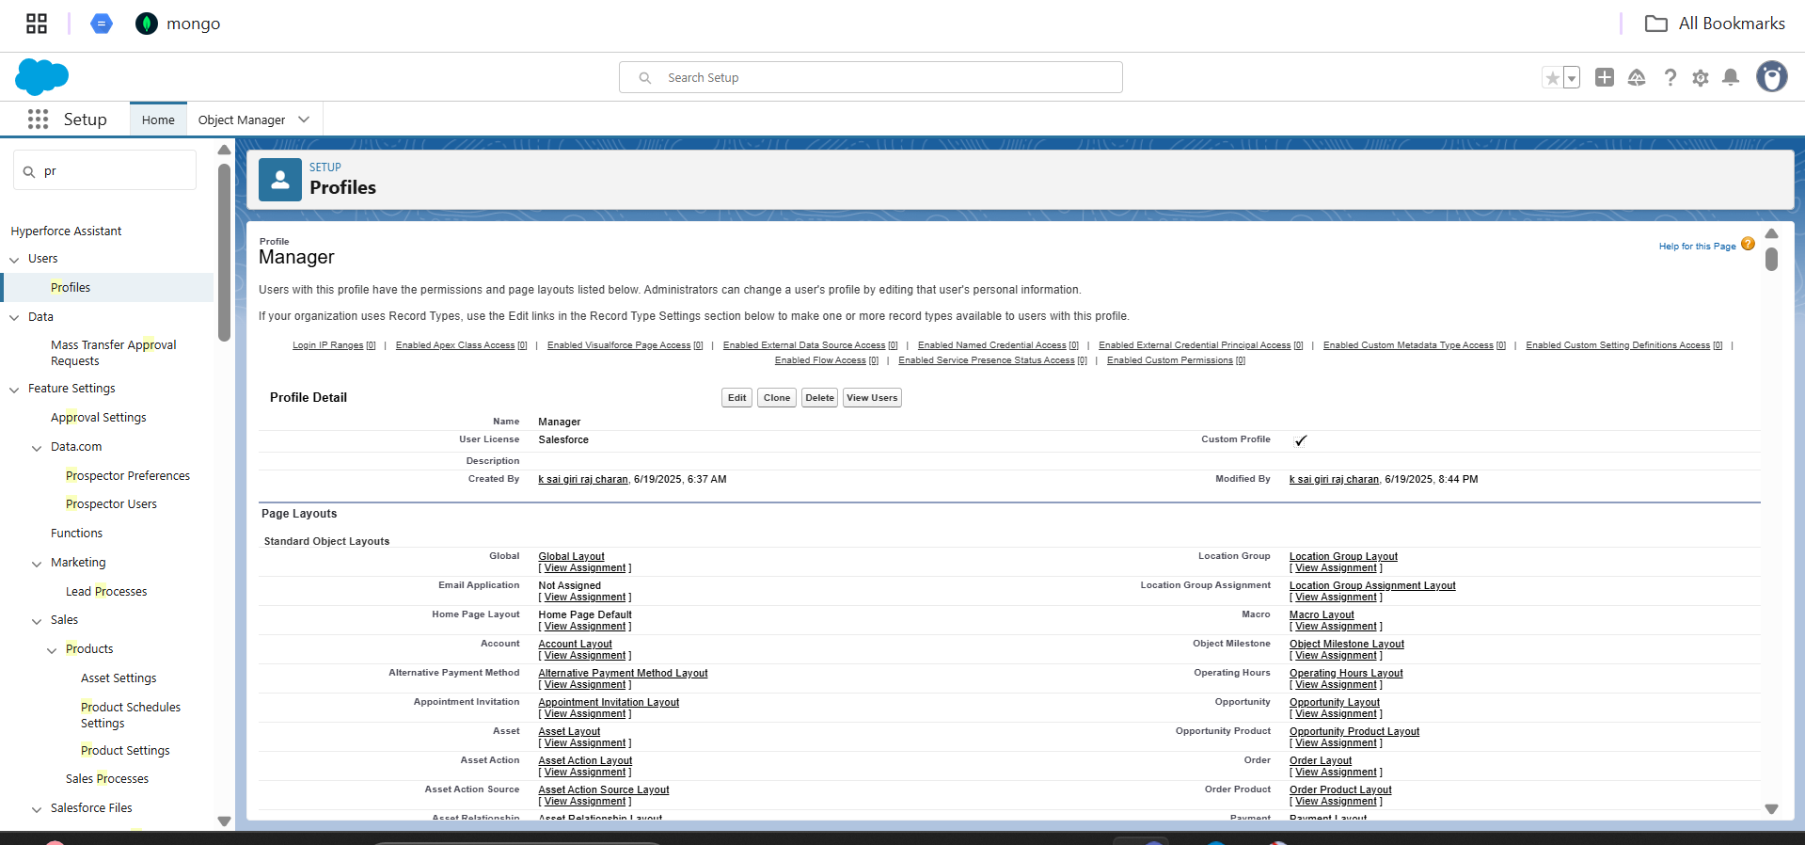

Sharing Settings:

Default External Access: Most objects are set to "Public Read Only" or "Private."

Custom Object Sharing:

Billing details and feedback: Public Read/Write

Customer Details: Public Read/Write

Service records: Public Read/Write

Appointment: Public Read/Write

Automation (Flows & Apex):

Flow: Billing Amount Flow - V1

Type:

Record-Triggered Flow (triggered when a record in "Billing details and feedback" is created or updated).

Steps:

Start: Triggered on creation/update of "Billing details and feedback" records.

Account Update: Updates a record (details not fully visible, but likely related to an account).

Email Alert: Sends an email notification.

Recipient Details: Configured to send emails to the email address associated with the "Appointment" and "Customer Details" (Appointment.Customer_Details.Email).

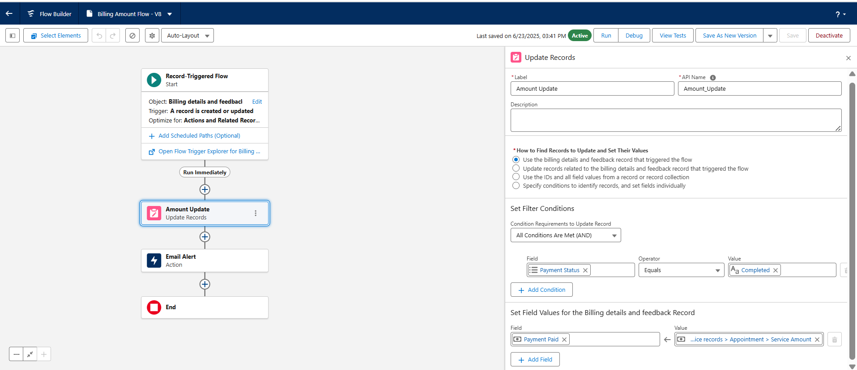

Flow: Update Service Status - V1

Type: Record-Triggered Flow (triggered when a record in "Service records" is created or updated).

Purpose: Automatically updates the Service_Status__c field to "Completed" when Quality_Check_Status__c is True.

Steps:

Start: Triggered on creation/update of "Service records."

Service Status (Update Records): Updates the Service_Status__c field.

Condition: Quality_Check_Status__c equals True.

Set Field Value: Service_Status__c is set to "Completed".

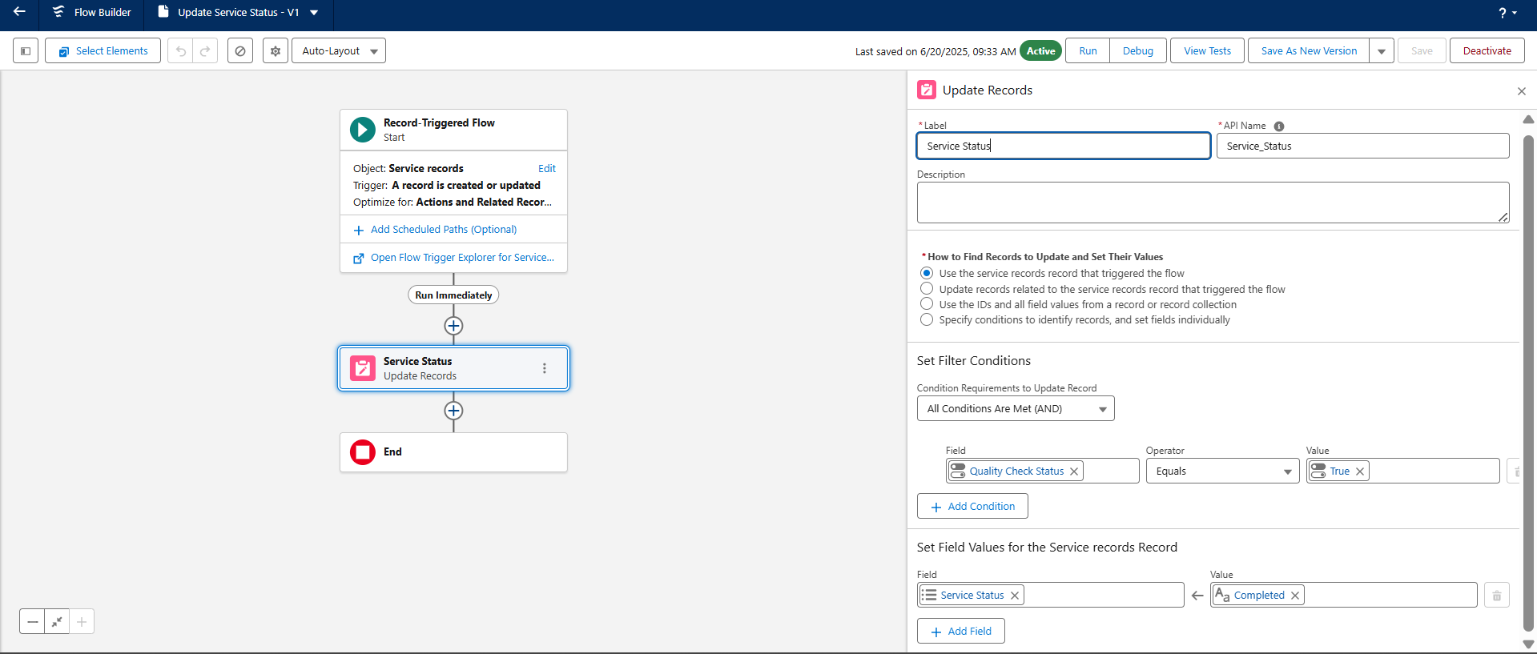

Apex Class: AmountDistributionHandler.apxc

amountDist Method:

Takes a list of Appointment__c records as input.

Iterates through each appointment.

Conditional Logic for Service_Amount__c:

If Maintenance, Repairs, and Replacement Parts are all true: Service_Amount__c = 10000

If Maintenance and Repairs are true: Service_Amount__c = 5000

If Maintenance and Replacement Parts are true: Service_Amount__c = 8000

If Repairs and Replacement Parts are true: Service_Amount__c = 7000

If only Maintenance is true: Service_Amount__c = 2000

If only Repairs is true: Service_Amount__c = 3000

If only Replacement Parts is true: Service_Amount__c = 5000

Screenshot Reference: Refer to "AmountDistributionHandler.apxc" screenshots for the code.

Apex Trigger: AmountDistribution.apxt

Object: Appointment__c

Trigger Events: before insert, before update

Purpose: Invokes the amountDist method from the AmountDistributionHandler class before an Appointment__c record is inserted or updated. This ensures that the Service_Amount__c is calculated automatically based on the selected services.

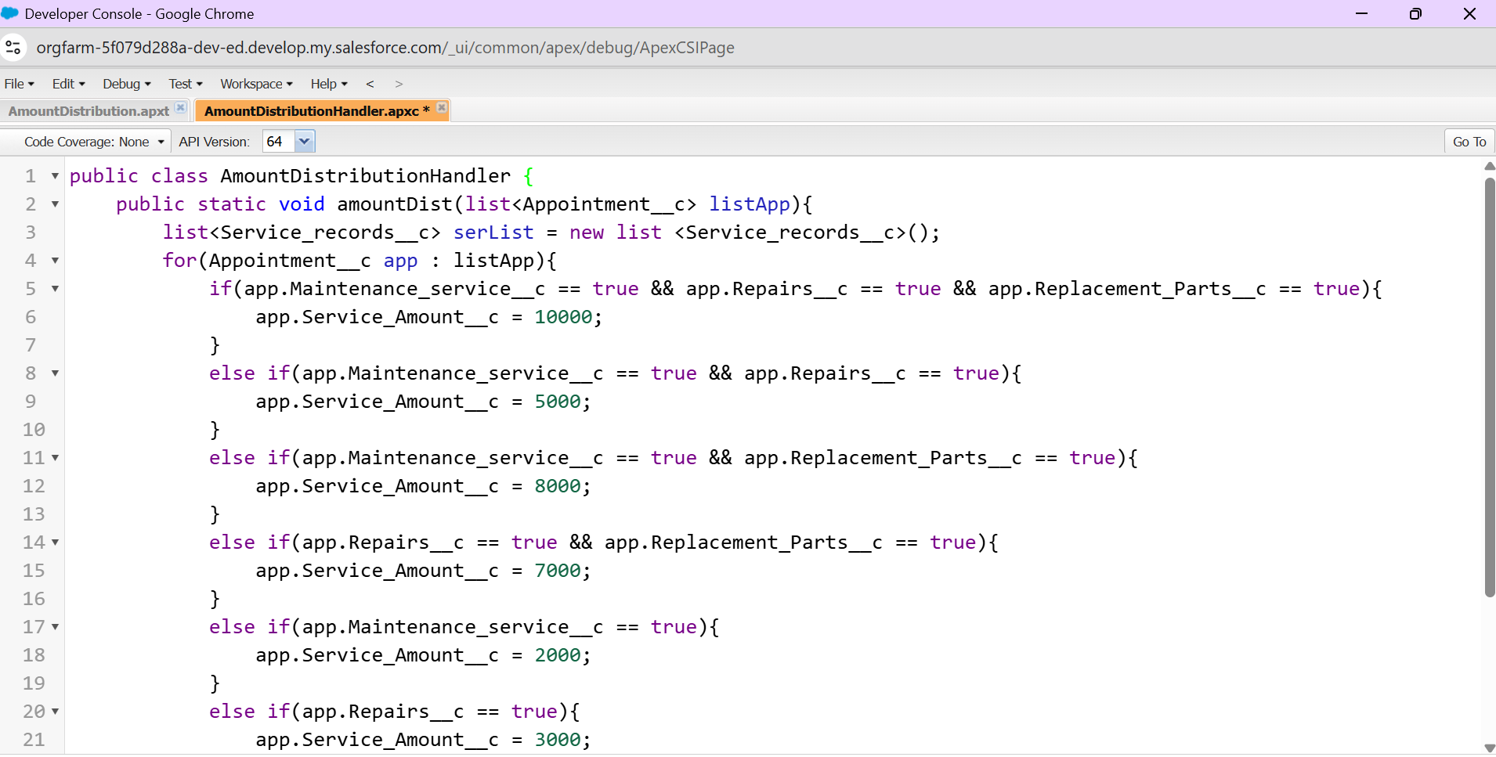 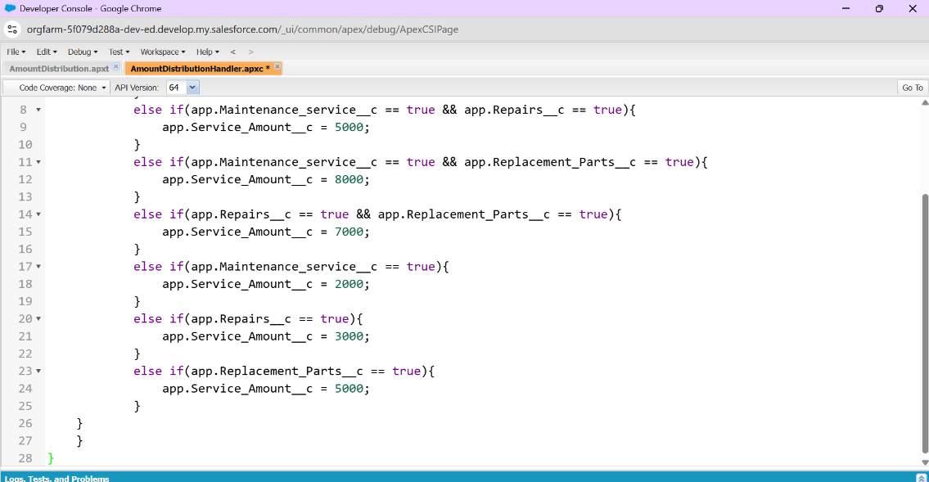

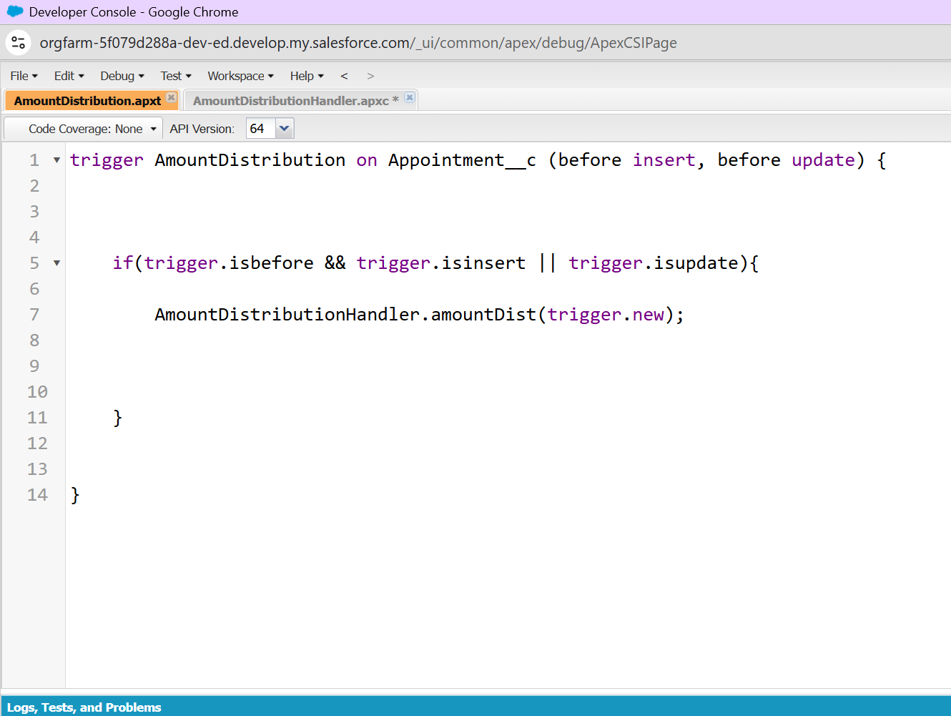

Reports and Dashboards:

Report:

New Service Information Report

Total Payment Paid: Shows a sum of $40,000 for 10 records.

Chart: Displays "Sum of Payment Paid" against "Rating for service."

Details: Includes information like Service Status, Service Amount, Customer Name, Appointment Date, and Payment Paid.

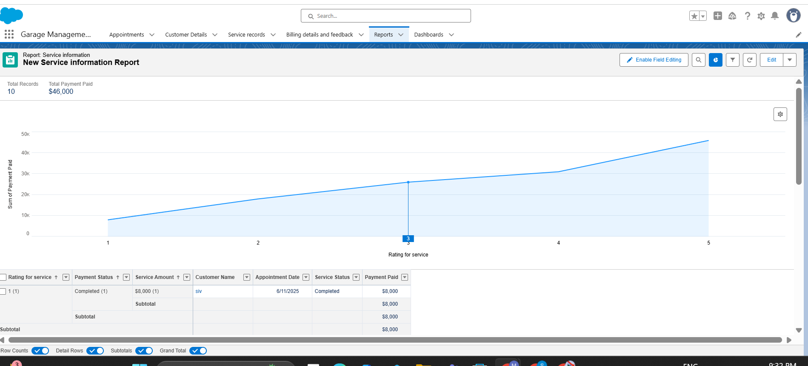

Dashboard: Customer review

Component: Includes the "New Service Information Report" chart, visualizing "Sum of Payment Paid" against "Rating for service" with different rating values (1-5) plotted.

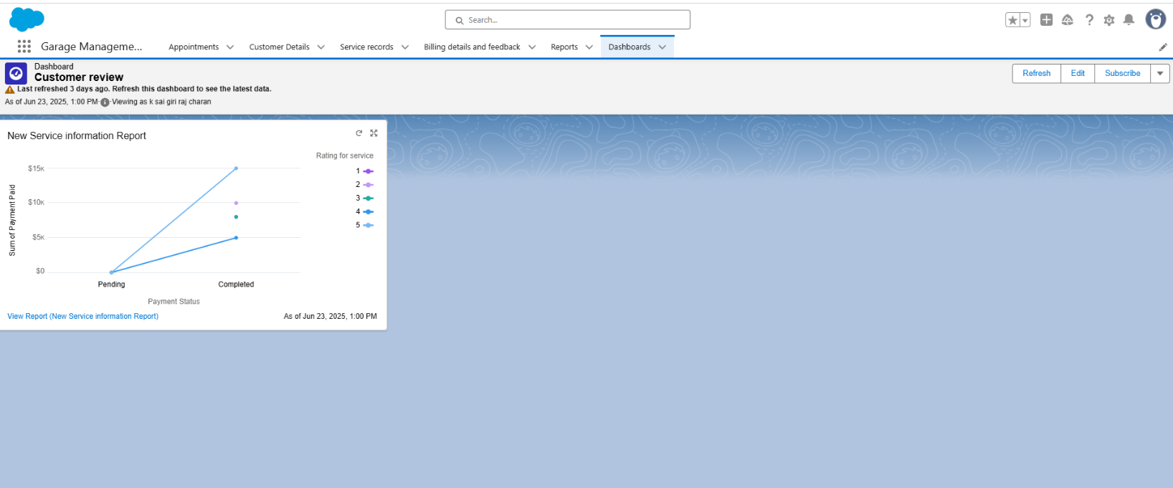

Key Records (Illustrative):

Appointments:

Screenshot shows a list of appointments, e.g., app-016, app-000, app-007, etc.

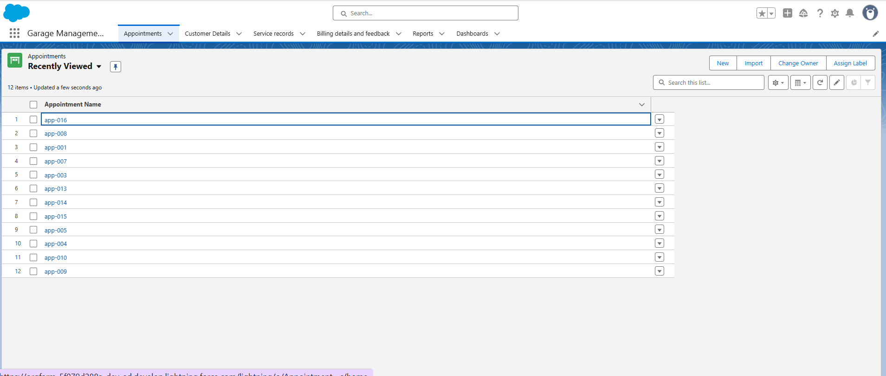

Customer Details:

Screenshot shows a list of customer names, e.g., vv, uu, nn, Mix, Salesforce user123.

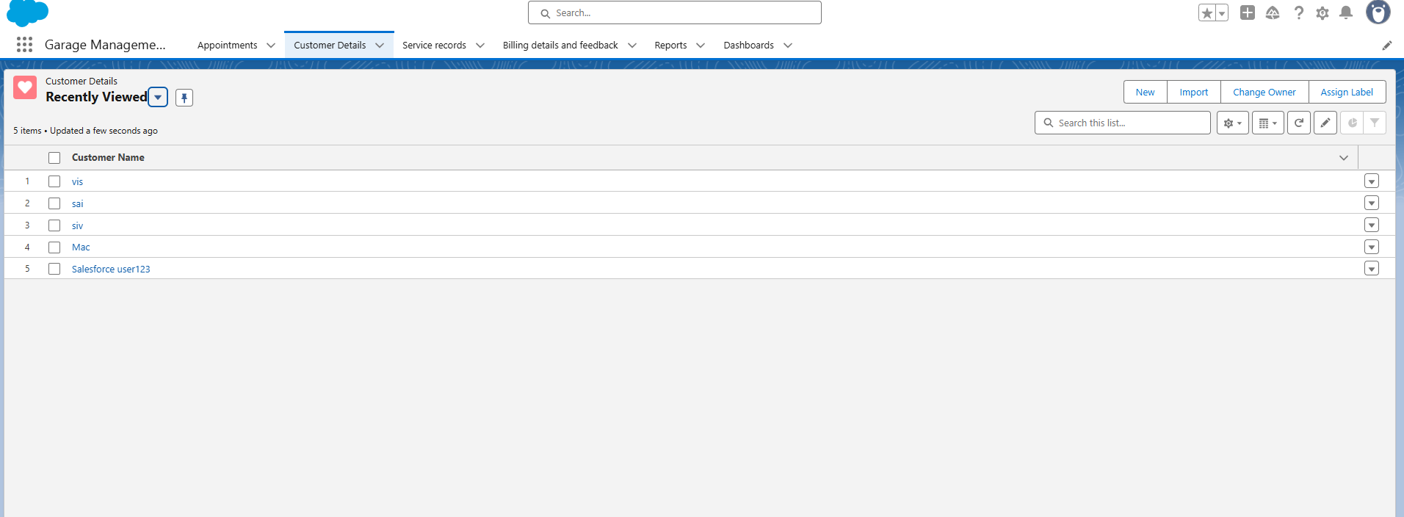

Service Records:

Screenshot shows a list of service records, e.g., ser-026, ser-023, ser-024, etc.

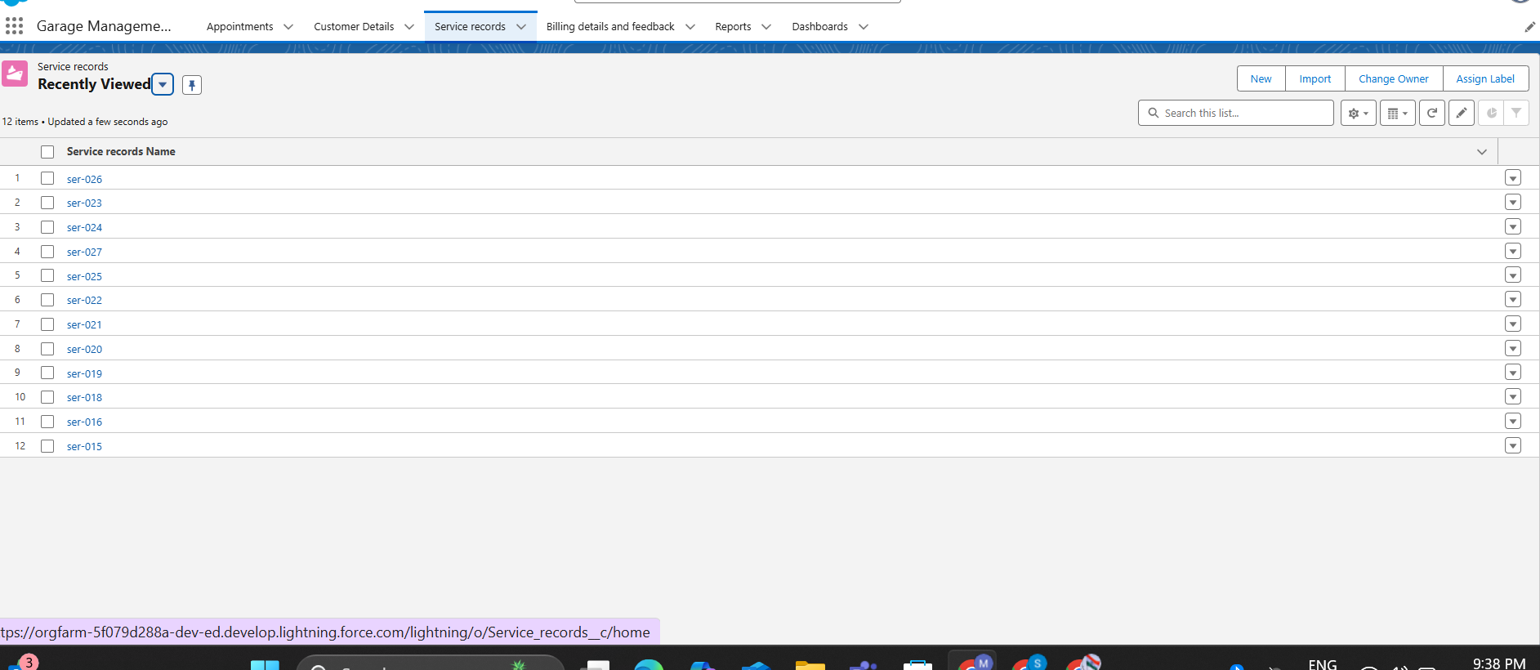

Billing details and feedback:

Screenshot shows a list of billing and feedback records, e.g., bill-024, bill-023, bill-000, etc.

